INDEX
S.No | Excerices | Date | Signture

- Write a program to show multiplication of 2 matrices in C.
#include<stdio.h>
#include<conio.h>
void main()
{
int arr[100][100],brr[100][100],crr[100][100],m,n,y,z,i,j,sum,k;
// clrscr();

printf("Emter rows and columns of first matrix : ");
scanf("%d %d",&m,&n);
printf("Emter rows and columns of second matrix : ");
scanf("%d %d",&y,&z);

if(n==y)
{
// first matrix input
printf("Enter elements of first matrix : ");
for(i=0;i<m;i++)
{
printf("enter %d row : ",i+1);
for(j=0;j<n;j++)
{
scanf("%d",&arr[i][j]);
}
}
// second matrix input
printf("Enter elements of second matrix : ");
for(i=0;i<y;i++)
{
printf("enter %d row : ",i+1);
for(j=0;j<z;j++)
{
scanf("%d",&brr[i][j]);
}
}

//multiplication
for(i=0;i<m;i++)
{
for(j=0;j<z;j++)
{
sum=0;
for(k=0;k<n;k++)
{
sum+=arr[i][k]*brr[k][j];
}
crr[i][j]=sum;
}
}
//final matrix
for(i=0;i<m;i++)
{
for(j=0;j<z;j++)
{
printf("%d ",crr[i][j]);
}
printf("\n");
}
}
else
{
printf("matrices can not be multiplied ");
}
getch();
}

OUTPUT :
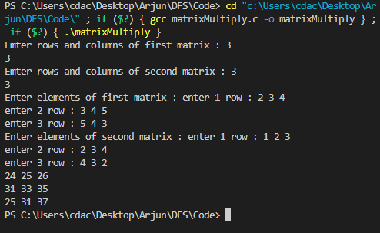

2. Write a Program in C to transpose a square matrix .
#include<stdio.h>
#include<conio.h>
void main()
{
int arr[100][100],n,i,j,tmp=0;
// clrscr();
printf("Emter order of matrix : ");
scanf("%d",&n);
printf("Enter elements of matrix : ");
for(i=0;i<n;i++)
{
printf("enter %d row : ",i+1);
for(j=0;j<n;j++)
{
scanf("%d",&arr[i][j]);
}
}
for(i=0;i<n;i++)
{
for(j=0;j<n;j++)
{
printf("%d ",arr[i][j]);
}
printf("\n");
}

for(i=0;i<n;i++)
{
for(j=0;j<i;j++)
{
tmp=arr[i][j];
arr[i][j]=arr[j][i];
arr[j][i]=tmp;

}
printf("\n");
}

for(i=0;i<n;i++)
{
for(j=0;j<n;j++)
{
printf("%d ",arr[i][j]);
}
printf("\n");
}

getch();
}

OUTPUT
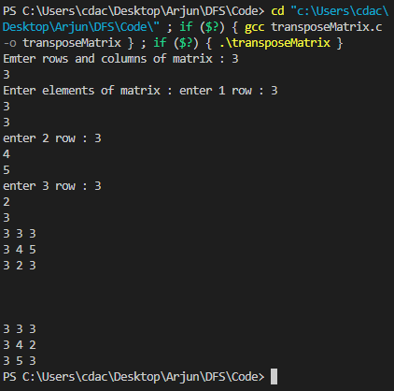

3. Write a program in C to implement Linear Search.
#include<stdio.h>
#include<conio.h>
void main()
{
int arr[100],n,i,elem,found=0,foundpos=-1;
printf("Emter size of array : ");
scanf("%d",&n);

printf("Enter elements of array : ");
for(i=0;i<n;i++)
{
scanf("%d",&arr[i]);
}

printf("Enter the element you want to search : ");
scanf("%d",&elem);
// linear search

for(i=0;i<n;i++)
{
if(arr[i]==elem)
{
found=1;
foundpos=i+1;
break;
}

}
if(found==1)
{
printf("Element found at %d position",foundpos);
}
else
{
printf("Element not found");
}

getch();
}

OUTPUT:
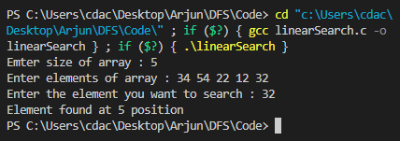

4. write a program in C to implement Bubble Sort.
#include<stdio.h>
#include<conio.h>
void main()
{

int arr[100],n,i,j,tmp;
printf("Emter size of array : ");
scanf("%d",&n);
printf("Enter elements of array : ");
for(i=0;i<n;i++)
{
scanf("%d",&arr[i]);
}
for(i=0;i<n;i++)
{
for(j=0;j<n-i-1;j++)
{
if(arr[j]>arr[j+1])
{
tmp=arr[j];
arr[j]=arr[j+1];
arr[j+1]=tmp;
}
}
}
for(i=0;i<n;i++)
{
printf("%d ",arr[i]);
}
getch();
}

OUTPUT:
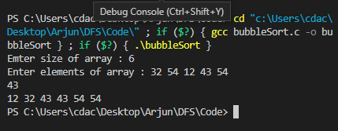
5. Write a program to implement a stack and its operations using an array in C.
#include<stdio.h>
int arr[10],top=0,n;
// push operation
void push()
{
int x;
if(top==10)
{
printf("stack overflow");
}
else
{
printf("Enter the item ");
scanf("%d",&x);
arr[top++]=x;
}
}
// pop operation
void pop()
{
if(top==0)
{
printf("stack underflow");
}
else
{
top--;
}
}
// display
void display()
{
int i;
for(i=0;i<top;i++)
{
printf("%d ",arr[i]);
}
}

void main()
{
while(1)
{
printf("1.Push\n");
printf("2.Pop\n");
printf("3.Display\n");
scanf("%d",&n);
if(n==1)
push();
else if(n==2)
pop();
else if(n==3)
display();
else
printf("Wrong choice");
}
}

OUTPUT:
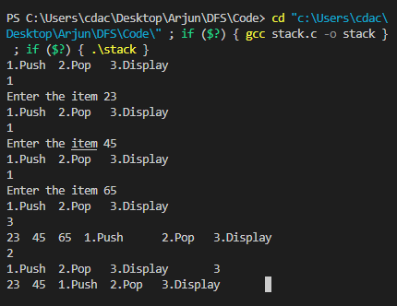
6. Write a program to implement a Queue and its operations using an array.
#include<stdio.h>
#include<stdlib.h>
int arr[5],front=0,rear=0,n,capacity=5,elements=0;
void insert()
{
int x;
if(elements==capacity)
{
printf("queue overflow\n");
}
else
{
printf("Enter the item ");
scanf("%d",&x);
arr[rear]=x;
elements++;
rear=(rear+1)%10;
}
}
void Delete()
{
if(elements==0)
{
printf("queue underflow\n");
}
else
{
elements--;
front=(front+1)%10;
}
}
void display()
{
int i;
for(i=front;i!=rear;)
{
printf("%d ",arr[i]);
i=(i+1)%10;
}
printf("\n");
}
void main()
{
while(1)
{
printf("1.insert\n");
printf("2.Delete\n");
printf("3.Display\n");

scanf("%d",&n);
if(n==1)
insert();
else if(n==2)
Delete();
else if(n==3)
display();
else if(n==4)
exit(0);
else
printf("Wrong choice\n");
}
}

OUTPUT:
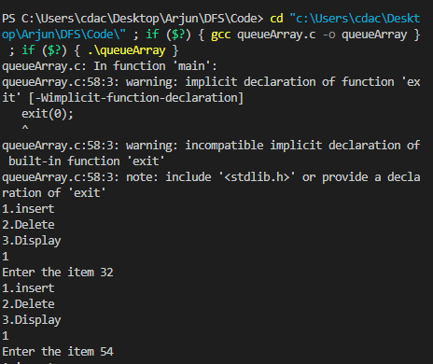
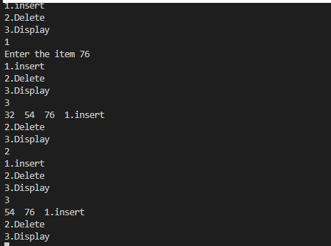

7. Write C program to find factorial of n using :
(i)Recursion
#include<stdio.h>
int fact(int n)
{

if(n==1)
return 1;
return n*fact(n-1);

}

void main()
{
int n;
printf("Enter the number : ");
scanf("%d",&n);
printf("factorial is : %d",fact(n));
}

OUTPUT:
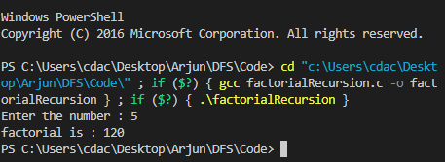
(ii) Iteration
#include<stdio.h>
void main()
{
int n,fact=1,i;
printf("Enter the number : ");
scanf("%d",&n);
for(i=1;i<=n;i++)
{
fact*=i;
}
printf("factorial is %d : ",fact);
}

OUTPUT:
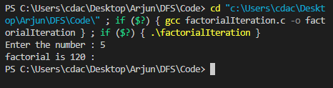

8. Write C programs to compute nth Fibonacci using :
(i) Recursion
#include<stdio.h>
int fibo(int n)
{
if(n==0)
return 0;
else if(n==1)
return 1;
return fibo(n-1)+fibo(n-2);
}

void main()
{
int n;
printf("Enter the term you want to find : ");
scanf("%d",&n);
printf("fibbonaci's %d term is : %d",n,fibo(n));
}

OUTPUT:
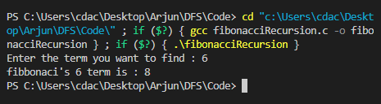

(ii) Iteration
#include<stdio.h>
void main()
{
int n,fibo,fst=0,scnd=1,i;
printf("Enter the term you want to find : ");
scanf("%d",&n);
if(n==0)
fibo=fst;
else if(n==1)
fibo=scnd;
else
{
for(i=2;i<=n;i++)
{
fibo=fst+scnd;
fst=scnd;
scnd=fibo;
}
}
printf("fibbonaci's %d term is : %d",n,fibo);
}

OUTPUT:
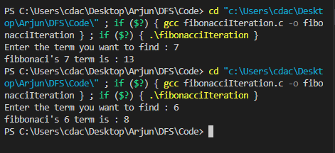

9. Write a program in C to implement Binary Search.
#include<stdio.h>
#include<conio.h>
int binsrch(int *arr,int low,int high,int key)
{
int mid=(low+high-1)/2;
if(arr[mid]==key)
return mid;
if(low>=high)
return -1;
if(key>arr[mid])
return binsrch(arr,mid+1,high,key);
else
return binsrch(arr,low,mid-1,key);
}
int main()
{

int arr[100],n,i,key,pos;
printf("Enter the number of elements : ");
scanf("%d",&n);
printf("Enter the elements(sorted)");
for(i=0;i<n;i++)
{
scanf("%d",&arr[i]);
}

printf("Enter the element you want to search : ");
scanf("%d",&key);
pos=binsrch(arr,0,n,key);
if(pos==-1)
{
printf("not found");
}
else
{
printf("Element at %d ",pos+1);
}
getch();
return 0;
}

OUTPUT:
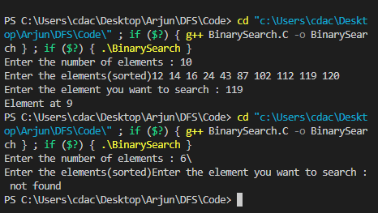
10. Write a program in C to implement Insertion sort.
#include<stdio.h>
#include<conio.h>
void main()
{

int arr[100],n,i,temp,j;
printf("Enter the number of elements : ");
scanf("%d",&n);
// input of elements
printf("Enter the elements");
for(i=0;i<n;i++)
{
scanf("%d",&arr[i]);
}

// Insertion sort
for(i=1;i<n;i++)
{
for(j=i;j>0;j--)
{
if(arr[j]<arr[j-1])
{
temp=arr[j];
arr[j]=arr[j-1];
arr[j-1]=temp;
}
else
{
break;
}
}
}

printf("sorted array \n");
for(i=0;i<n;i++)
printf("%d ",arr[i]);
getch();
}

OUTPUT:
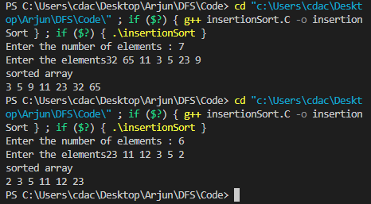

11 . Write a program in C to implement Selection Sort.

#include<stdio.h>
#include<conio.h>
void main()
{

int arr[100],n,i,min,minpos,j;
// clrscr();
printf("Enter the number of elements : ");
scanf("%d",&n);
// input of elements
printf("Enter the elements");
for(i=0;i<n;i++)
{
scanf("%d",&arr[i]);
}

// selection sort
for(i=0;i<n-1;i++)
{
min=arr[i];
minpos=i;
for(j=i+1;j<n;j++)
{
if(arr[j]<min)
{
min=arr[j];
minpos=j;
}
}
arr[minpos]=arr[i]; //swapping of min element
arr[i]=min;
}
printf("sorted array \n");
for(i=0;i<n;i++)
printf("%d ",arr[i]);
getch();
}

OUTPUT:
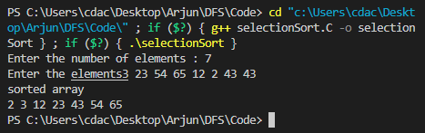

12. Write a program to implement linked list and its operations in C.
#include<stdio.h>
#include<stdlib.h>
// structure
struct node
{
int data;
struct node *next;
};

// traversing
void display(struct node *head)
{
struct node *tmp=head;
if(tmp==NULL)
{
printf("No node found");
}
else
{
while(tmp!=NULL)
{
printf("%d ",tmp->data);
tmp=tmp->next;
}
}

printf("\n");
}

// Insertion at Beginning
struct node* insertBeg(struct node *head)
{
struct node *newnode=(struct node*)malloc(sizeof(struct node*));

printf("Enter the data : ");
scanf("%d",&newnode->data);

struct node *tmp=head;
head=newnode;
newnode->next=tmp;

return head;

}

// Insertion at End
struct node* insertEnd(struct node *head)
{
struct node *newnode=(struct node*)malloc(sizeof(struct node*));

printf("Enter the data : ");
scanf("%d",&newnode->data);
struct node* temp=head;
if(head==NULL)
{
head=newnode;
newnode->next=NULL;
}
else
{
while(temp->next!=NULL)
{
temp=temp->next;
}
temp->next=newnode;
newnode->next=NULL;
}
return head;

}

// Insert at Position
struct node* insertPos(struct node *head)
{
struct node *newnode=(struct node*)malloc(sizeof(struct node*));
int pos,i=2;
printf("Enter the data : ");
scanf("%d",&newnode->data);

printf("Enter the position : ");
scanf("%d",&pos);

struct node* temp=head;
if(head==NULL)
{
head=newnode;
newnode->next=NULL;
}
else if(pos==1)
{
newnode->next=head;
head=newnode;

}
else
{
while(temp->next!=NULL&&i<pos)
{
temp=temp->next;
i++;
}
newnode->next=temp->next;
temp->next=newnode;
}
return head;

}

// Delete from Beginning
struct node* deleteBeg(struct node* head)
{
struct node* temp=head;
if(head==NULL)
{
printf("No nodes present to delete !!!");
}
else
{
head=head->next;
free(temp);

}
display(head);
return head;

}

// Delete from End
struct node* deleteEnd(struct node* head)
{
struct node* temp=head;
struct node* ptr=head;
if(head==NULL)
{
printf("No nodes present to delete !!!");
}
else if(temp->next==NULL)
{
head=NULL;
free(temp);
}
else
{
while(temp->next!=NULL)
{
ptr=temp;
temp=temp->next;

}
ptr->next=NULL;
free(temp);
}
display(head);
return head;

}

// Delete from Position
struct node* deletePos(struct node* head)
{
struct node* temp=head;
struct node* ptr=head;
int pos,i=1;
printf("Enter the Position : ");
scanf("%d",&pos);
if(head==NULL)
{
printf("No nodes present to delete !!!\n");
}
else if(pos==1)
{
head=head->next;
free(temp);
}
else
{
while(temp->next!=NULL&&i<pos)
{
ptr=temp;
temp=temp->next;
i++;

}
if(i<pos)
{
printf("No node at that position !!\n");
}
else
{
ptr->next=temp->next;
free(temp);

}

}
display(head);
return head;

}

// searching in list
void search(struct node *head)
{
int data,i=1;
struct node* temp=head;
printf("Enter the data you want to search : ");
scanf("%d",&data);
while(temp!=NULL)
{
if(temp->data==data)
{
printf("found at %d node \n",i);
return;
}
temp=temp->next;
i++;

}
printf("not found");

}

// reversing the linked list
struct node* reverse(struct node* head)
{
struct node *temp=NULL,*ptr;
while(head)
{
ptr=head->next;
head->next=temp;
temp=head;
head=ptr;
}
display(temp);
return temp;
}
void main()
{ struct node* head=NULL;
int choice;
while(1)
{
printf("\n");
printf("Enter the choice : \n");
printf("0. Exit\n");
printf("1. Display whole list\n");
printf("2. Insert at Beginning\n");
printf("3. Insert at End\n");
printf("4. Insert at Position\n");
printf("5. Delete from Beginning\n");
printf("6. Delete from End\n");
printf("7. Delete from Position\n");
printf("8. Search an Element\n");
printf("9. Reverse the linked List\n");
scanf("%d",&choice);
switch(choice)
{
case 0: exit(0);
break;
case 1: display(head);
break;
case 2: head = insertBeg(head);
break;
case 3: head = insertEnd(head);
break;

case 4: head = insertPos(head);
break;

case 5: head = deleteBeg(head);
break;

case 6: head = deleteEnd(head);
break;

case 7: head = deletePos(head);
break;

case 8: search(head);
break;
case 9: head=reverse(head);
break;
}
}
}

OUTPUT:
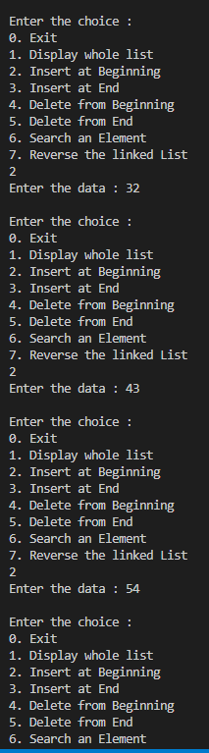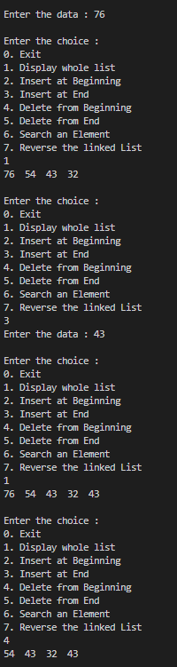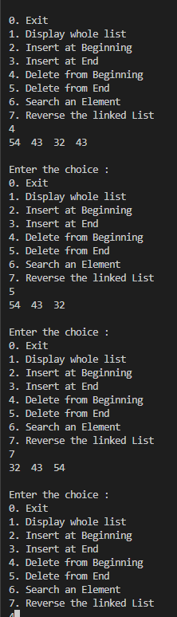

13. Write a program in C to implement merge sort.
#include<stdio.h>

void merge(int *,int,int,int); //declaration of merge

void mergeSort(int *arr,int low,int high)
{
int mid;
if(low>=high)
return;
mid=(low+high)/2;
mergeSort(arr,low,mid);
mergeSort(arr,mid+1,high);
merge(arr,low,mid,high);

}

void merge(int *arr,int low,int mid,int high)
{
int i=low,j=mid+1,temp[100],pos=low,x;
while((i<mid+1)&&(j<=high))
{
if(arr[i]>arr[j])
{
temp[pos++]=arr[j];
j++;
}
else
{
temp[pos++]=arr[i];
i++;
}
}

// for remaining elements
while(i<mid+1)
{
temp[pos++]=arr[i];
i++;
}

while(j<=high)
{
temp[pos++]=arr[j];
j++;
}

for(x=low;x<=high;x++)
{
arr[x]=temp[x];
}

}

void main()
{
int n,arr[100],i;

printf("Enter size of array : ");
scanf("%d",&n);

printf("Enter elements of array : ");
for(i=0;i<n;i++)
{
scanf("%d",&arr[i]);
}

mergeSort(arr,0,n-1);

printf("Sorted array : ");
for(i=0;i<n;i++)
{
printf("%d ",arr[i]);
}
}

OUTPUT:
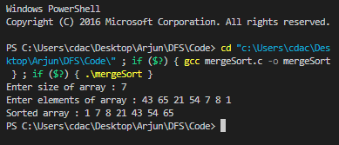

14. Write a program in C to implement quick sort.
#include<stdio.h>

int findPivot(int *arr,int low,int high)
{
int pivot=low,temp;
while(low<=high)
{
while(arr[low]<=arr[pivot])
low++;

while(arr[high]>arr[pivot])
high--;

if(low<high)
{
temp=arr[low];
arr[low]=arr[high];
arr[high]=temp;
}

}

// placing pivot to right position
temp=arr[pivot];
arr[pivot]=arr[high];
arr[high]=temp;
return high;

}

void quickSort(int *arr,int low,int high)
{
if(low>=high)
return; //termination case
int pivot=findPivot(arr,low,high);
quickSort(arr,low,pivot-1);
quickSort(arr,pivot+1,high);

}

void main()
{
int n,arr[100],i;

printf("Enter size of array : ");
scanf("%d",&n);

printf("Enter elements of array : ");
for(i=0;i<n;i++)
{
scanf("%d",&arr[i]);
}

quickSort(arr,0,n-1);

printf("Sorted array : ");
for(i=0;i<n;i++)
{
printf("%d ",arr[i]);
}
}

OUTPUT:
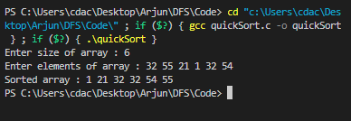

15. write a program in C to implement a queue using 2 stacks.
#include<stdio.h>
#include<conio.h>
#include<stdlib.h>

struct node
{
int data;
struct node* next;
}*s1,*s2;

void enqueue()
{
int value,x;
struct node* temp;
struct node *actualnode=(struct node*)malloc(sizeof(struct node*));
printf("Enter the data you want to insert : ");
scanf("%d",&value);
//transfer all from s2 to s1
while(s2!=NULL)
{

struct node *newnode=(struct node*)malloc(sizeof(struct node*));
temp=s2;
s2=s2->next;
x=temp->data;
free(temp);
newnode->data=x;
if(s1==NULL)
{
s1=newnode;
newnode->next=NULL;
}
else
{
newnode->next=s1;
s1=newnode;
}
}
// actual data goes to s1 top

actualnode->data=value;
if(s1==NULL)
{
s1=actualnode;
actualnode->next=NULL;
}
else
{
actualnode->next=s1;
s1=actualnode;
}

}

void dequeue()
{
int x;
struct node* temp;
//transfer everything from s1 to s2
while(s1!=NULL)
{
struct node *newnode=(struct node*)malloc(sizeof(struct node*));
temp=s1;
s1=s1->next;
x=temp->data;
free(temp);

newnode->data=x;
if(s2==NULL)
{
s2=newnode;
newnode->next=NULL;
}
else
{
newnode->next=s2;
s2=newnode;
}
}
// actual deletion
if(s2==NULL)
{
printf("Underflow\n");
}
else
{
temp=s2;
s2=s2->next;
free(temp);
}

}

void display()
{
struct node *temp;
//print all if it is in stack1
if(s1!=NULL)
{
temp=s1;
while(temp!=NULL)
{
printf("%d ",temp->data);
temp=temp->next;
}

}
//print all if it is in stack2
else if(s2!=NULL)
{
temp=s2;
while(temp!=NULL)
{
printf("%d ",temp->data);
temp=temp->next;
}

}
//both stacks empty
else
{
printf("nothing to show !!!!!");
}

}

void main()
{
int choice;
while(1){
printf("Enter your choice\n");
printf("1. EnQueue\n");
printf("2. DeQueue\n");
printf("3. Display\n");
scanf("%d",&choice);
switch(choice)
{
case 1:enqueue();
break;
case 2:dequeue();
break;
case 3:display();
break;
case 0:exit(0);
break;
}
}
}

OUTPUT:
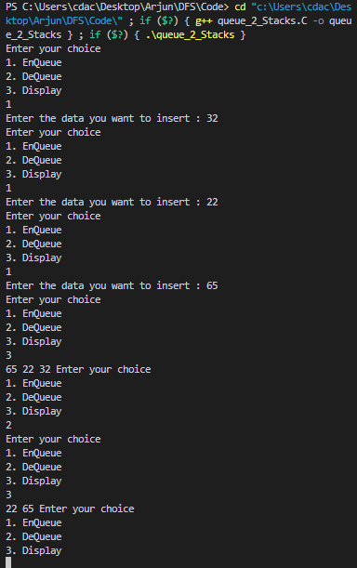

16. Write a program in C to show Tree traversal.
#include<stdio.h>
#include<stdlib.h>
struct node
{
int data;
struct node *right;
struct node *left;
};
struct node* insertData(struct node* root)
{
int data;
struct node *temp,*prv;
struct node *newnode=(struct node*)malloc(sizeof(struct node *));
printf("enter the data : ");
scanf("%d",&data);
newnode->data=data;
newnode->left=NULL;
newnode->right=NULL;
if(root==NULL)
{
root=newnode;
}
else
{
temp=root;
while(temp)
{
prv=temp;
if(data<temp->data)
{
temp=temp->left;
}
else
{
temp=temp->right;
}
}
if(data>prv->data)
prv->right=newnode;
else
prv->left=newnode;

}
return root;
}

//inorder traversal left->root->right
void inorder(struct node *ptr)
{
if(ptr==NULL)
return;
inorder(ptr->left);
printf("%d ",ptr->data);
inorder(ptr->right);
}

//preorder traversal root->left->right
void preorder(struct node *ptr)
{
if(ptr==NULL)
return;
printf("%d ",ptr->data);
preorder(ptr->left);
preorder(ptr->right);
}

//postorder traversal left->right->root
void postorder(struct node *ptr)
{
if(ptr==NULL)
return;
postorder(ptr->left);
postorder(ptr->right);
printf("%d ",ptr->data);
}

int main()
{
struct node *root=NULL;
while(1)
{
int ch;

printf("Enter your choice : \n");
printf("1. Insert Data : \n");
printf("2. Preorder traversal\n");
printf("3. Postorder traversal\n");
printf("4. Inorder traversal\n");
scanf("%d",&ch);
switch(ch)
{
case 1: root=insertData(root);
break;
case 2: preorder(root);
printf("\n");
break;
case 3: postorder(root);
printf("\n");
break;
case 4: inorder(root);
printf("\n");
break;
case 0: exit(0);
break;
}
}
return 0;

}

OUTPUT:
